PROPERTY & HOME INSPECTION REPORT
Prepared on: August 23, 2026 • AI Multi-Photo Inspection Engine

1. Executive Summary
The overall inspection of this area reveals critical structural defects in the concrete masonry unit (CMU) foundation wall. Horizontal and stair-step fracturing across multiple courses indicates lateral soil pressure or foundation movement/settlement pushing inward against the wall structure. Additionally, exposed electrical wiring and receptacle boxes lack required physical protection and proper junction enclosures. Immediate evaluation by a licensed structural engineer and follow-up repairs by qualified contractors are strongly recommended.

2. Inspector Field Notes & Scope
Field notes provided state 'test'. Visual examination reveals significant structural foundation wall distress behind exposed wood stud framing, including continuous horizontal and stair-step cracking in the concrete block wall, as well as unprotected electrical wiring.

3. Detailed Photo-by-Photo Inspection Findings

Photo #1: Basement CMU Wall, Framing & Exhaust Duct
Condition Assessment: Critical Concern
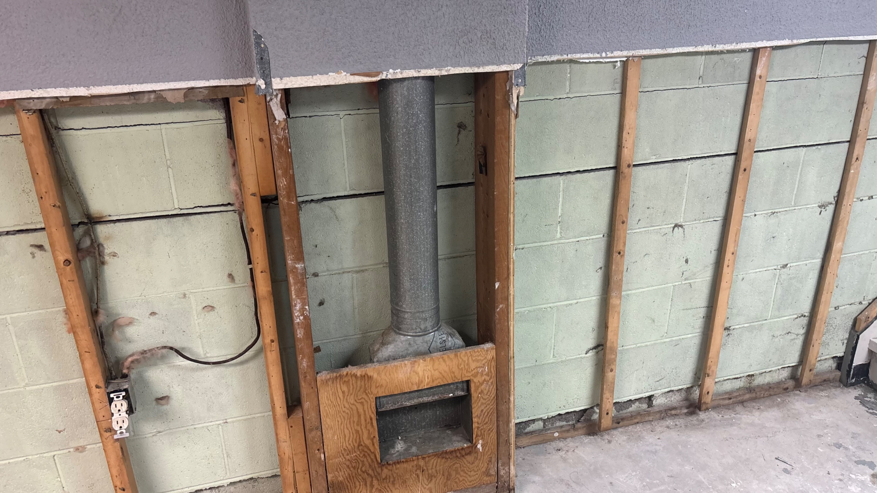
Detailed Observations: View of a partially framed concrete masonry unit (CMU) foundation wall. A long horizontal crack is visible running continuously across the block wall behind the wood studs. A metal duct pipe extends down into a rough wooden chase. Non-metallic sheath cable (Romex) is loosely attached to framing studs, terminating at an open electrical receptacle box.
Recommendations: Have a licensed structural engineer evaluate the foundation wall for inward deflection and structural integrity. Ensure electrical wiring is properly secured and protected within finished wall cavities or conduit in accordance with local electrical code.

Photo #2: Concrete Block Foundation Structural Crack
Condition Assessment: Critical Concern
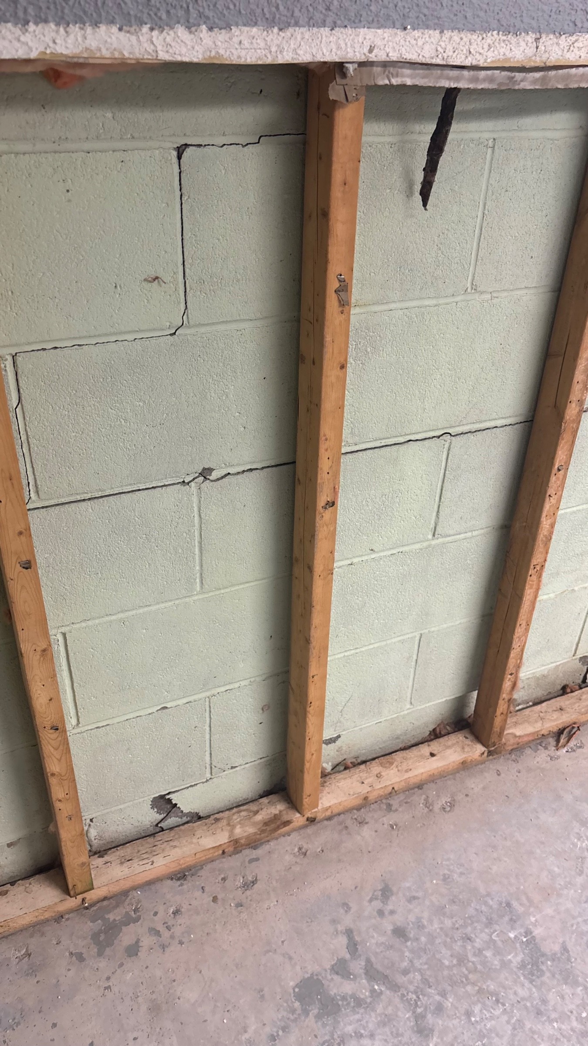
Detailed Observations: Close-up of the CMU foundation wall showing severe horizontal cracking along the mortar joint that transitions into vertical shearing through concrete blocks. This type of cracking is a key sign of lateral soil pressure or hydrostatic force against the foundation wall exterior.
Recommendations: Obtain an engineering design for foundation stabilization (e.g., carbon fiber straps, steel I-beam bracing, or wall anchors). Check exterior grading, gutters, and downspout management to minimize hydrostatic pressure against the exterior wall.

Photo #3: Foundation Wall Shear Crack & Unprotected Wiring
Condition Assessment: Critical Concern
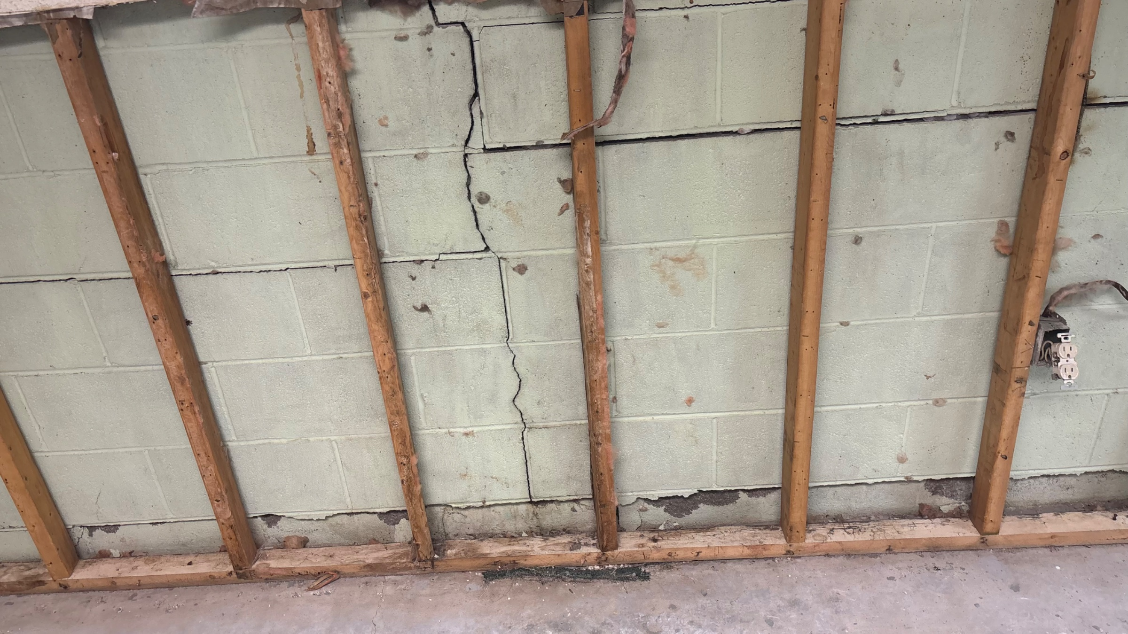
Detailed Observations: Wide continuous stair-step and vertical fracture extending top-to-bottom across multiple block courses. Deterioration and spalling are visible near the wall base at the concrete floor junction. An exposed electrical outlet box is surface-mounted to a stud without wall protection.
Recommendations: Perform urgent structural repairs as specified by a structural engineer. Hire a licensed electrician to safely install, box, and cover all electrical components.

4. Hazards & Critical Safety Concerns
• Potential structural failure or wall collapse hazard due to significant horizontal and stair-step cracking in the load-bearing CMU foundation wall under lateral earth pressure.
• Shock and fire hazard from exposed non-metallic electrical cable and un-enclosed receptacle box mounted on open wood framing.

5. Prioritized Action Plan & Next Steps
1. Immediate Evaluation: Hire a licensed Structural Engineer to conduct a thorough evaluation of the foundation wall and prescribe a structural reinforcement plan.
2. Foundation Repair: Retain a qualified foundation repair contractor to execute structural reinforcement (e.g., wall anchors, carbon fiber reinforcement, or steel beams).
3. Water & Drainage Correction: Inspect exterior perimeter, clean/extend downspouts, and adjust grade away from the foundation to prevent water accumulation and hydrostatic pressure.
4. Electrical Safety: Hire a licensed electrician to secure loose electrical wiring and install proper code-compliant boxes, covers, and wall protection.

DISCLAIMER & LIMITATIONS
This report is generated using automated computer vision and multimodal artificial intelligence based strictly on provided visual evidence and field observations. It does not replace a full on-site destructive structural assessment or warranty against concealed defects.

